Michael Martin

IT210

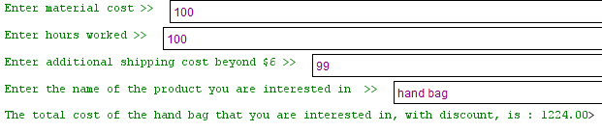

Although this program works as intended, I am still struggling with the “get” and “set” commands while using multiple classes. I tried to follow the book but it didn’t work very well for me and I got confused in a couple of places. If you put a “0” in for the shipping cost, it will calculate a standard $6 for shipping. I hope this is ok.

Farrell, J. (2016). Java programming (8th ed.). Boston, MA: Cengage Learning.